**Targets:**

1-) Generate 20% loan growth at the end of the simulation.

2-) Maintain AFTR/DEPOSIT ratio at 10% level at each time interval.

3-) Maximize net interest income of the bank.

**Hints:**

**How to reach loan target ?**

1-) Find initial loan balance from balance sheet. (BS_REPORT)

2-) Find the future cashflows of the loans in 12 months from liquidity gap report. (LIQGAP_REPORT)

3-) Calculate the target loan production amount.

4-)Calculate the monthly target loan production amount.

**What is reserve requirement ?**

You should allocate 10% of your liabilities at the central bank. Your closing cash balance should be at least the reserve requirement amount.



**What is Total Repo Capacity ? (AFTR:** **Available funds through repo)**

You can receive funding by repo transactions. With the repo transaction, your securities will be placed to your counterparty as colleteral for the funding you receive. In the simulation the funding amount will be % 10 lower than the security amount you place. (Meaning that there is %10 repo haircut)

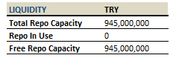

**What is AFTR/Deposit ratio ?**

The ratio is calculated by dividing the total repo capacity to total deposit amount. This is an indicator showing how liquid the bank is. It is the percentage of deposit outflow that the bank can sustain.

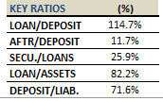

**What is Net Interest Income Report ?**

Net Interest Income: Interest income received from assets minus interest cost paid to liabilities during a specific period of time. Net interest income report shows the net interest income of your balance sheet of a specific time period.

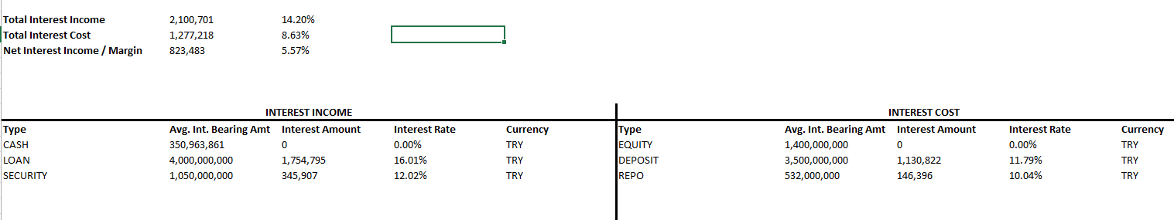

**What is NIM ?**

Net interest income / Interest bearing assets

**What is Liqudity Gap Report ?**

A table that shows the amount of future cash inflows and outflows, and suggests the gap the bank has to close.

